(Approx. 816 words)

A Brief Tour of the VLC Media Player
By Tom Burt, Vice-President
Sun City Summerlin Computer Club
https://www.scscc.club
tomburt89134 (at) cox.net

The free VLC Media Player, by non-profit VideoLAN Corporation, is a useful and powerful program for playing all types of audio and video files, including video DVD and Blu-ray disks. It also is able to convert audio and video files from one format to another.

The VLC Media Player has versions for Windows, Mac OS and LINUX. You can download it from: www.videolan.org. The VLC installer from the VideoLAN website does not attempt to install any extra junk-ware, but always pay attention as you click through the setup dialogs. During the setup, you can choose the audio and video file types for which VLC will become the default player. Once VLC is installed, double clicking on one of its file types, such as .MP4 files, will launch VLC to “play” that file.

VLC can directly play Adobe Flash Videos (.FLV files) downloaded from web video sharing sites such as YouTube.com. This can be helpful if you want to build your own collection of YouTube videos and play them on your PC monitor or even stream them to your HDTV.
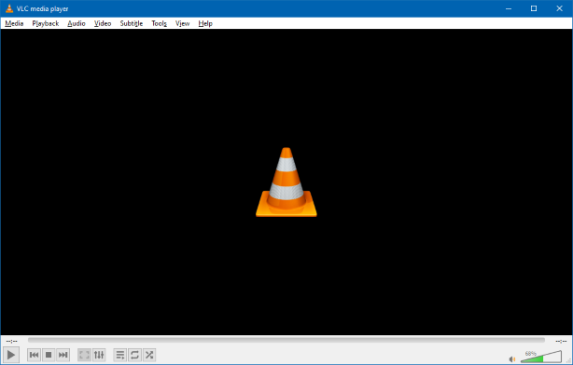
As you can see in the above screen shot, the VLC user interface is quite simple, featuring a menu bar at the top, the main video window and then player and volume controls at the bottom.

Media Menu
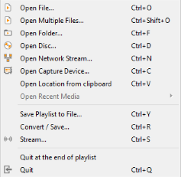
The VLC Media menu is the gateway to all operations involving files. Commonly, if you have double clicked a media file, VLC will just start up and play that file.

However, VLC can also play audio/video directly from a capture device, such as a camcorder or it can play audio/video from a network stream, such as an Internet radio or TV station.

The Convert / Save function allows you to convert a set of files from one type to another – for example from .WMV to .MP4 or from .AAC to .MP3. We’ll look at this in more detail below.

Playback Menu / Control
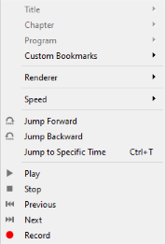
The Playback menu allows you to control the playback of the media file. Within a file you can control the playback speed (faster or slower), jump forward or backward or to a specific time.

If playing multiple files or a playlist, you can skip forward or backward to the next or previous file.

You can also record whatever is playing. This can be handy if playing a streaming video.

The Playback control at the bottom of the VLC window offers a set of graphical controls to manage playback.

Audio Menu
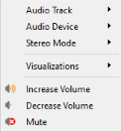
When playing an audio file, the Audio menu lets you control the audio playback, including turning on visualizations, stereo mode (stereo, left track, right track), what audio device to send the sound to, which track to play of a multi-track set, such as a CD.

You can also control the volume, although that is easier to do with the Windows volume control at the lower right of the screen.

Video Menu
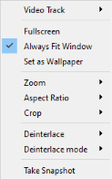
When playing a video file or disc, the Video menu lets you control the video playback. You can control which video track is played, switch to full screen and back and set the zoom factor and the aspect ratio of the video window.

You can crop the original video to only show part of the video on the screen. You can specify whether and how the original video should be deinterlaced. And you can grab a particular video frame as a single image.

Media File Conversion
Finally, let’s explore the VLC Media Conversion tool.
On the Media menu, click “Convert / Save”. The following dialog will open with an empty file list. Click the Add… button to add one or more files to the list to convert. The Convert/Save dropdown at the bottom right will become enabled. Click the down-arrow and then choose Convert.
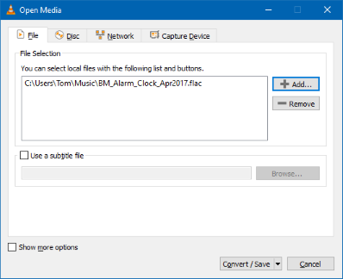
That will open a second dialog (see below) showing the name of the source file. In the dropdown at the middle, choose the desired resultant file type.

In this example, we are converting a music file format called .FLAC to the more common .MP3 file format. However, you can convert to and from many audio and video file formats. A common format conversion is camcorder .MOV video files to .MP4 video files for posting to YouTube or Facebook.

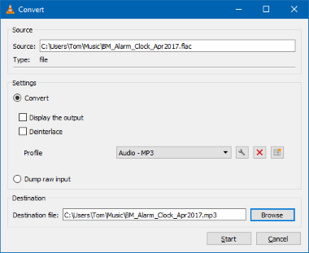
Once everything is set up, just click the Start button in the lower right of the dialog and the file conversion(s) will proceed.

The time required by VLC to perform a conversion will depend on the size and complexity of the file. Audio files are usually done in a few tens of seconds. Videos may take quite a bit longer.

So, that’s a quick look at some of the features of VLC. I’ve only covered the basics. There are many more features in this very powerful program. Give it a try yourself.

